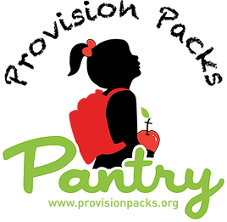

Provision Packs 2022/23 School Year Partner Agreement

First and foremost, we just want to take a moment and thank you for all you do for the kids in your schools. We are excited to be partnering with you this year.

Please complete the section below and email to carrie@provisionpacks.org .

- Our first bags will be distributed on August 26th (for those schools who are ready).
- A minimum of 2 volunteers are needed for delivering packs. Please supply their information below.
- If you cannot find volunteers to deliver, please let us know ASAP so that we can try to assist in your search.
- Please text weekly bag numbers to 386-295-9823 by end of day on Tuesday. If bag count is not updated, we will go with the numbers from last update. We do our best to send reminders.
- We ask that discretion is used when distributing our weekly packs.
Provision Packs
289 Walnut St.
Ormond Beach, FL 32174

School Contact:
Name & Title: _________________________ Cell: _______________________

Email Address: _________________________

Volunteers Delivery: If you have an occasional, last-minute delivery need, please call Carrie ASAP at 386-295-9823. Although we cannot guarantee, we will do our VERY best to get your kids their packs.

- Name ______________________ Cell ________________________

- Name ______________________ Cell ________________________

- Name ______________________ Cell ________________________

We are looking forward to another amazing school year! Please email carrie@provisionpacks.org with any questions or concerns.

Sincerely, Provision Packs Board of Directors

